Safety instruction
1. Precautions to be taken to avoid damage during installation, such as dropping sharp objects or stepping on the heating unit, or careless pouring of concrete.
2. Dimensions and distances to be taken into account.
According to the proportion of heating area for the practical area of 60% , for example 10m² area was installed with 6 m² heating module. Please refer to the design drawings for details.
3. A statement that the heating units have to be separated from other heat sources such as luminaires and chimneys.
4. Description of the fixing areas of the heating unit.
1. The ground shall be dry, firm and free of Sundries, and the flatness shall be ≤2mm / 2m.
2. In the door frame, the top, walls and other interior decoration projects completed, the floor can only be constructed, should not be cross-construction with other projects。
3. When designing, please reserve the floor height space: the floor heating product is about 3.5 cm thickness, the total floor height of the wet paving is about 8 cm, (according to the calculation of 3cm cement mortar, 1.5 cm ceramic tile) . For old house, the heating module can be installed on the original floor (wooden floor, ceramic tile) directly, no need to remove the ground construction, please note that the increase in the height of the floor to mark sure the door can be open and close。
5. Guidance on how to avoid air gaps between the heating element and the screed of concrete floors.
The heating module is flat, and after the concrete floor has made the leveling layer, it can be smoothly fitted to the bottom of the heating module, the gaps between the heating modules and between the modules and the wall, and the extrusion board is cut and filled according to the requirement of the site size to do the thermal insulation, the gap between the heating module and the extrusion plate is pasted with aluminum foil adhesive tape.
6. Guidance on how to avoid damage to a heating element and its terminations in timber
constructions due to relative movement after installation.
To install the heating module floor heating, it should prevent paint, asphalt, or other chemical solvent contact, pollution of the surface of the heating module. The heating module shall not be interleaved with other jobs when installation; shall not be drilled, drilled or nailed on heating module. At the end of the paving, the floor heating shall be tested and accepted, including heating, wiring, sealing head, leakage test and appearance, etc. . Delivered to the next stage of construction (refers to the filling laying of the surface layer of the construction) , when the filling layer above the floor heating is strictly prohibited in the use of mechanical vibration.
7. Warning: against incorporating heating units below a height of 2,3 m into walls or into ceilings inclined at less than 45° to the vertical.
8. The lowest ambient temperature at which heating units may be installed.
Minimum operating ambient temperature of the heating module:-40 °C
9. The installation is to be in accordance with the national wiring rules.
10. The heating units are to be supplied through a residual current device (RCD) having a rated residual operating current not exceeding 30 mA.
11. How to connect heating units to the supply, giving the cross-sectional area of the Leads.
The cross-sectional are of the lead shall be at least 4mm²
12. How to interconnect the heating units, giving the cross-sectional area of the leads.
The cross-sectional are of the lead connected to thermal control shall be at least 4mm²
13. list of controls, those controls that are necessary to ensure compliance with the standard IEC/EN60730 need be listed.
Thermal control requirement:
- Rated current/ power cover with the rated current / power after installation. Recommend 80% rated current of thermal control.
- Included internal and external sensor.
- The thermal control complied with IEC/EN 60730.
- Complied with local regulations and legal requirements
It is also can sell together with our suggest model R6500G thermal control

14. the maximum thermal resistance between the heating unit and the room.
15. The type of covering materials that are allowed to be used in conjunction with the heating units with a statement that the advice of the manufacturer is to be requested before materials other than those recommended are used; the thickness of covering materials, which for floors shall be at least 5 mm.
16. Characteristics of the thermal insulation that is to be inserted between separate heating units installed to heat a floor.
The space between each heating module is filled by measuring dimensions, cutting plastic extrusion plate on site,Make the house better heat preservation performance。
17. statement that a label is to be fixed adjacent to the distribution board and that it has to contain the locations of the heating units;

19. A grid is to be installed above the heating unit. The grid is to:
– be protected against corrosion but not electrically insulated;
– fully cover the heating unit including the fixing areas. It may cover several heating units;
– be fitted with terminals suitable for the connection of two conductors each having a nominal cross-sectional area of 2,5 mm²;
– be checked for electrical continuity during installation.
20. When the heating units have been positioned, they must be covered with an additional layer of material for mechanical protection. If the heating units are placed on concrete, a similar layer is to be inserted between the heating unit and the concrete. Adjacent layers are to overlap and be fixed to each other. The layer is to extend up each wall to the
surface level of the screed.
21. The heating units are to be installed at a distance of at least 30 mm from conductive parts of the building, such as water pipes
22. Installation in concrete.
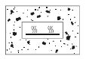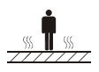

23. The flexible sheet heating element is to be fully covered by the ceiling or floor;
24. The metallic parts of the floor are to be earthed. The instructions shall state that they have to be fitted with terminals suitable for the connection of two conductors each having a nominal cross-sectional area of 2,5 mm² and explain how the connection to the earthing terminal is to be made to ensure a low resistance.
25. If the supply cord is damaged, it must be replaced by the manufacturer, its service agent or similarly qualified persons in order to avoid a hazard.
26. This appliance can be used by children aged from 8 years and above and persons with reduced physical, sensory or mental capabilities or lack of experience and knowledge if they have been given supervision or instruction concerning use of the appliance in a safe way and understand the hazards involved. Children shall not play with the appliance. Cleaning and user maintenance shall not be made by children without supervision.
Added how to use the appliance

地暖禁止长时间有大面积且较厚重的物体覆盖（如毛巾、衣物、毛毯、被褥以及落地
家具等）Floor heating is prohibited for a long time to have a large area and heavier objects covered (such as towels, clothing, blankets, bedding and floor furniture, etc.)
地暖禁止泡水，如有水或其他液体洒落地面，应及时使用地拖、干抹布等工具使地板保持干爽Floor heating prohibit soaks water, if have water or other liquid is aspersed fall ground, should use the tool such as mop in time, dry dishcloth to make the floor maintains dry and cool
地暖及温控器属于电器类产品，禁止自行修理、自行更换电源线路，否则可能引致事故。
Floor heating and temperature controller are electrical products. It is forbidden to repair or replace the power supply line by yourself. Otherwise, it may cause an accident.
禁止用湿手操作温控器，有触电的危险Do not use wet hands to operate the thermostat. It may cause electric shock
禁止用消毒剂、清洁剂、清水、可燃性喷雾材料直接喷射温控器, 可能会引起火灾或触电危险。Do not use disinfectants, detergents, clear water, flammable spray materials directly sprayed thermostat, may cause fire or electric shock risk.
初次使用时的操作步骤
First-use procedures
①初次使用或长时间未启动，在温控器上设定15℃的温度开始加热，持续运行。
For initial use or long time without starting, set the temperature at 15 °C on the Thermostat to start heating, continuous operation.
②在15℃低温保持状态下运行，确保温控器正常工作至自动断开，初次使用，由于房间内墙、地面的冷辐射原因，运行时间较长。
Under the condition of 15 °C low temperature keeping, ensure the temperature controller working normally to automatically disconnect, the first use, because of the room wall, the floor of the cold radiation reasons, the running time is longer.
③达到15℃后，将设定温度调整至正常期望值（推荐值为18℃-22℃），系统即可按日常使用方式运行。
After reaching 15 °C, adjust the setting temperature to the normal expected value (the recommended value is 18 °c-22 °c) , the system can run according to the daily use mode.
Take the common temperature controller R6500 for example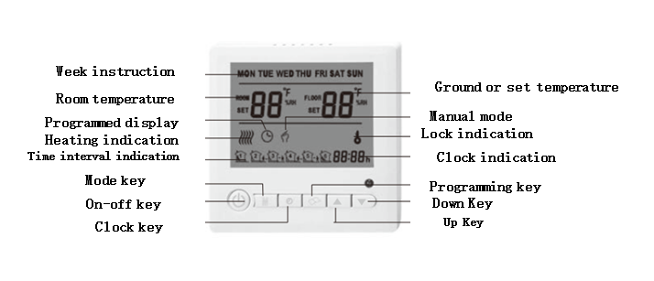

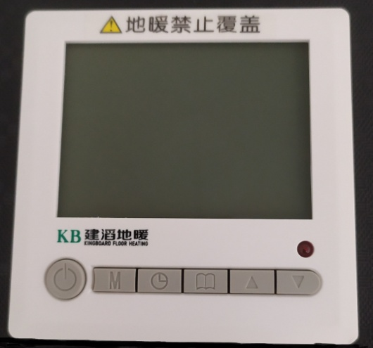
Key function and operation：
1.Press the power button，Control start or shut down, in the open state, LCD screen light, temperature controller according to the current mode operation.
The value on the left side of the screen shows room temperature。
2. Adjust the upper or lower keys to the desired temperature, usually 22 degrees more comfortable。The temperature setting is displayed on the right side of the screen
3. Long Press the Programming key for 3 seconds to enter the energy-saving mode。If any other temperature is required, Please adjust the key up or key down
4. When the room temperature reaches the set temperature, the thermostat automatically stops working.

系统使用说明及注意事项 Illustration of floor heating system and precautions to be taken
①室温20℃为最佳平衡温度，每提高1℃将增加6%左右的能耗，下调1℃减少4%的能耗；
The most favorable ambient temperature is 20℃. Every 1℃ rise would result in energy consumption to be increased by about 6%. Every 1℃ drop would result in energy consumption to be decreased by about 4%.

②采暖空间的最高温度为35℃（环境温度为-10℃条件下），最佳平衡温度为20℃，无人时保温温度以8~10℃为佳；
The most favorable ambient temperature range within the specific space is -10℃ to 35℃, the system can maintain the ambient temperature at 20℃ approximately.
③采暖房间应具备合理的保温措施，减少室内热量的散失，有效控制采暖系统运行的成本；
The specific place where the floor heating system is in operation should have measures to prevent heat from losing and thus control effectively the system operation cost
④！！！请勿用钉子或其他利器破坏地面，以免损坏地热层电线及接入电极引起漏电等事故；
Please do not use staple or other sharp mean to cause the surface damaged. Fail to do so would result in current leakage because of the ruined electrical wire in the system
⑤如因各种其他意外事故导致本系统发生故障，应立即联系我司以免引起安全事故；
In case the system is shut down due to other reasons rather than its internal fault, please inform relevant party as soon as possible to avoid other possible accidents
⑥电压正常波动不会影响本系统的使用，但有可能造成温控器的故障；
Voltage fluctuation would not affect the normal operation of this system, but would possibly cause thermostat lose function
⑦温控器工作寿命参见温控器产品的说明书，应根据其寿命及时予以更换。
User may have to take reference to the operation manual of the thermostat regarding its working life, replacement may be necessary if it has lost functions

 | This appliance complies with the current standards for this product type.
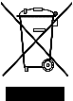 | This appliance carries the WEEE (Directive on waste electrical and electronic equipment) symbol, meaning that at the end of its life, it must not be disposed of with household waste but taken to a municipal recycling centre. Waste recycling contributes to preserving our environment.
建滔石墨烯地暖模块产品介绍
- 地暖模块产品的用途
The intended use of floor heating element
本产品适用于地面辐射供暖，是敷设在地面上用于取暖的设备。由保护层、石墨烯发热芯片、反射层和绝热层组成，在工厂预制压合成一体的石墨烯发热模块，上面需再铺设装饰面层。
This product is applicable to ground that can radiate heat , as a result of keeping warm war within specified area. It consists of protective layer, heating chip, reflective layer and insulation layer as well. All of the above will be pre-fabricated and thus form a complete Graphene Heating Element which is ready for use as long as being covered by a decorative material.
- 地暖模块产品结构
Structural diagram of Graphene Heating Element
保护层
石墨烯发热板
反射层
绝热层
图1 石墨烯发热模块剖面结构图

图2 模块产品结构图
连接电缆线

- 绝热层 Insulation Layer
用于阻挡热量向地面传递，减少无效热损失的构造层。其材料为硅酸钙板与挤塑板压合而成，挤塑板为聚苯乙烯发泡后挤压而成。
It serves the purpose of blocking heat loss to the ground. It is mainly composed of silicate thermal insulation integrated board and plastic extruded board.
- 反射层 Reflective Layer
用于反射红外热辐射，减少热量向下传递的构造层。其材料采用铝箔。
It is an Aluminium foil used to reduce infra-red heat dissipated to the lower layer.
- 石墨烯发热芯片 Heating chip
通电后能够发热的一种薄板，是由电绝缘材料及封装其内的石墨烯发热材料、防电容性漏电屏蔽结构组成的平面型发热元件。工作时将电能转化为热能，并将热能主要以辐射的形式向外传递。
It is a plane surface component which can generate heat when electric power is on. The risk of having capacitive leakage current is low as the electrical insulation material together with graphene heating element have been properly sealed. During operation, it converts electrical energy into heat energy, then dissipating to the surrounding by radiation.

- 保护层 Protective Layer
用于防止石墨烯发热芯片不被因裸露在外而受损的构造层。其材料是硅酸钙板，主要成分为石英砂、云母、珍珠岩、植物纤维、水泥。
The protective layer is to prevent the heating chip from being damaged. It is mainly composed of silicate thermal insulation integrated board, quartz sand, mica, perlite, plantfibre, cement.

- 连接电缆 Connecting wire
用于连接每一块发热板的电缆线，采用防水接头方式相连。
It is used to connect the power cable of every heating floor. The connection point is of waterproof design.
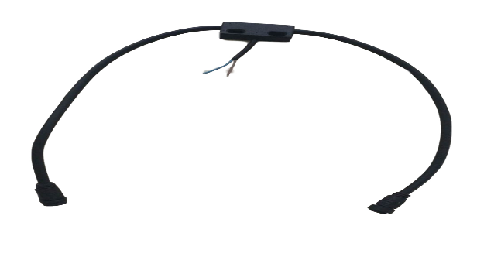
图2 连接电缆示意图

- 地暖模块产品图片 Views of the product
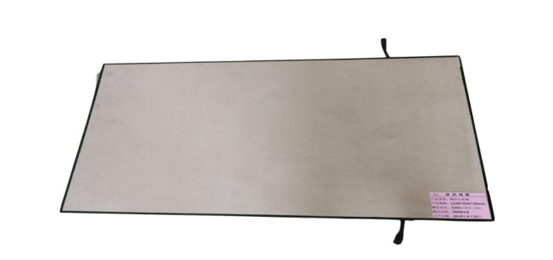
图4 产品正面图片
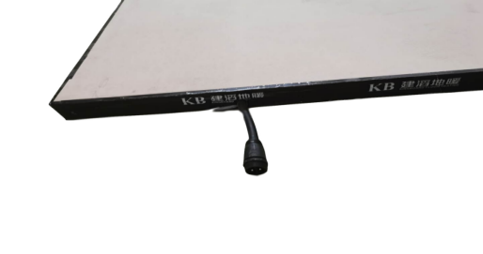
图5 产品侧面图

Front view Side view

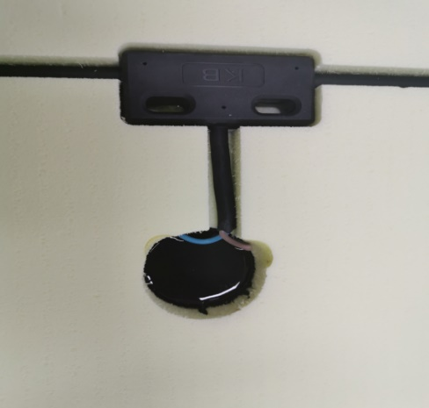
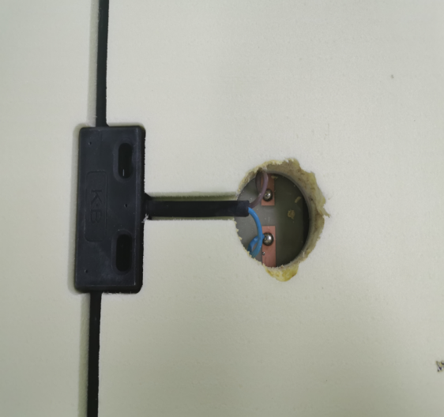
图6 封装前内部电路展示

图7 封装后内部电路展示
Internal circuitry before Internal circuitry after
potting adhesive applied potting adhesive applied

- 地暖模块产品规格 Product specification
型号  Model | 规格  Spec. | 电压  Operating voltage | 功率W/块  Power (W)/element
KBM01 | 810*1030 | 220-240V 50-60Hz | 250W

五、地暖模块产品安装构造 Installation guide
地暖模块敷设于地面后，水泥砂浆覆盖，然后铺设面饰层。
- Laid every floor heating element horizontally to the ground surface
- Pour cement onto top of the heating element until it becomes a smooth concrete floor
- Cover the floor with decorative material
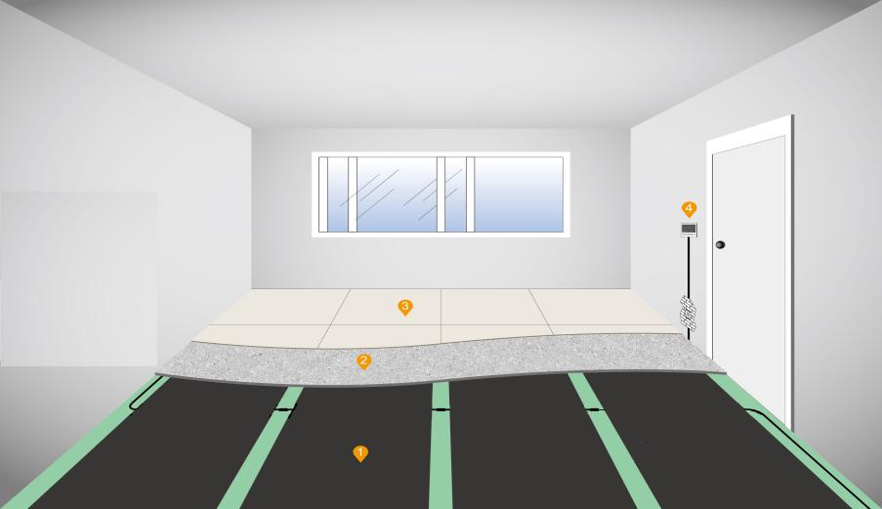
1、发热模块
2、水泥砂浆
3、饰面层
4、温控器

- 图8 安装示意图

Sketch of the installation
- Floor heating element 2. Cement motar 3. Decorative layer

图9 安装电路图
温度传感器
温度控制器
漏电开关
L
N

-Circuit breaker
- Thermostat
- Temperature transducer

面饰层
水泥填充层
发热模块
楼板

图10 系统构造图

发热模块

